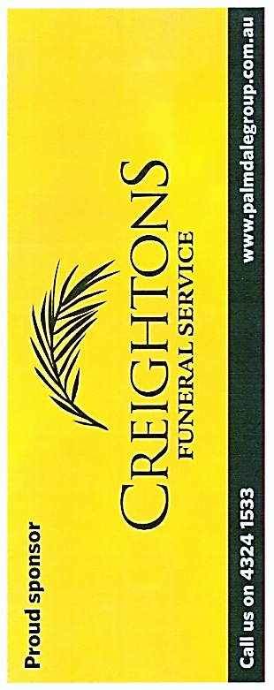ETTALONG MEMORIAL WOMEN’S BOWLING CLUB

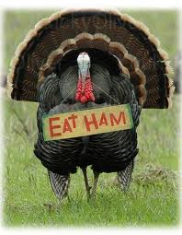



**MONDAY 25thNOVEMBER, 2019**

ENTRY FEE $45.00 PER TEAM

MORNING TEA 9.00 A.M. – PLAY COMMENCES 9.30 A.M.

LUNCH PROVIDED

PRIZES

1ST HALF HAM 2ND TURKEY BUFF 3rd CHICKEN 4TH XMAS CAKE

ENTRIES CLOSE 15th NOVEMBER, 2019

OR WHEN FILLED – 28 teams only

(NO REFUNDS AFTER CLOSING DATE)

**CONDITIONS OF PLAY – WET OR DRY**

1. 2 GAMES X 15 ENDS
2. WINNERS DECIDED BY:

WINS AND MARGINS (PLUS ENDS IF REQUIRED)

1. NO DEAD ENDS – JACK TO BE REPLACED ON “T”
2. 1 TRIAL END AM only

THE CONTROLLING BODY RESERVES THE RIGHT TO ALTER CONDITIONS OF PLAY IN ORDER TO BRING THE CARNIVAL TO A SATISFACTORY CONCLUSION.

ENTRIES TO

Mrs Robyn Holden, Hon. Secretary Home Phone: 0414762539

103 Springwood Street Women’s Club Phone: (02) 4344 5060

Ettalong NSW 2257

Email: womensbowls@ettalongbowlingclub.net

ENTRY FORM – HAM & TURKEY TRIPLES

ENTRY FEE $45.00 PER TEAM TO ACCOMPANY ENTRY FORM

If receipt required please send stamped addressed envelope.

**Full Name & Registration No. Club**

Lead:

Second:

Skip:

Contact Name & Phone No: